IDX G9 ENGLISH H STUDY GUIDE ISSUE 1
By Joyce and Isabella
Q: What are the main reasons for telling a story? List and explain the four primary functions.
A: 1) Metaphysical: to teach people about a society’s spiritual systems
2) Cosmological: to explain why the world is the way it is (before science was invented)
3) Sociological: to express cultural values and teach people how to be a part of their society
4) Pedagogical: to teach people about LIFE

Q: How are the women presented in myths? List the five main archetypes and explain them.
A: The Earth Mother – This character is symbolic of fulfilment, abundance, and fertility; offers spiritual and emotional nourishment to those who she contacts; often depicted in earth colours, with large breasts and hips.
The Temptress – Characterized by sensuous beauty, she is one whose physical attraction may bring about the hero’s downfall.
The Platonic Ideal – This source of inspiration often is a physical and spiritual ideal for whom the hero has an intellectual rather than physical attraction.
The Unfaithful Wife – This woman, married to a man she sees as dull or distant, is attracted to a more virile or interesting man.
The Damsel in Distress – The hero must rescue this vulnerable woman. She also may be used as a trap by an evil figure to ensnare the hero.
Q: What is feminism?
A: Ideology in which everyone could fight for gender equality. People argue against patriarchy in society and culture.

Q: What cultural anxieties do the Cyclops embody?
A: (Answer may vary) Hospitality (Xenia): In ancient Greece, hospitality, or xenia, was a sacred social custom. In ancient Greece, hosts were expected to provide travellers with food, shelter, and protection, while guests were expected to show gratitude and respect. When Odysseus and his men arrive at Polyphemus' cave, they expect the Cyclops to follow this norm. However, Polyphemus disregards xenia by capturing Odysseus and his men, eating some of them, and imprisoning the rest.

Q: How was the feminist theme expressed through “The Penelopiad” by Margret Atwood?
A: (Answer may vary) The text emphasises Penelope's intelligence and resourcefulness. The text portrays her as a woman who actively engages her mind and uses her wit to navigate challenges. Penelope also expresses empathy and remorse for the hanged maids, shedding light on the injustices faced by marginalised women in the story.

English H Level Study Guide
Lesson 1.8 Medusa
- Can you match Medusa with any of the archetypes?
Medusa fits with the scapegoat archetype. She is the sacrificial victim because
throughout the story she had done nothing wrong, it was Poseidon who raped her to
get revenge on Athena. Yet in the end, Medusa is the one turned into a hideous
monster.

- What does the story reflect of ancient Greek cultural social norms?
This story reflects ancient Greek cultural norms such as the importance of purity and virginity for women. It is evident that being a virgin is a highly regarded requirement for becoming one of Athena’s priestesses. Medusa’s tale also reflects the power dynamics between men and women. Even though Poseidon did the unworthy thing, at the end of the day, it was Medusa being punished

- In what ways is Medusa a victim of the patriarchal society?
The ways in which Medusa is portrayed as a victim of patriarchy are represented in the myth when Poseidon rapes her for revenge. Medusa was threatened and raped by Poseidon in Athena’s temple. Even though Poseidon assaulted Medusa, no one
blamed him. Instead, Athena blamed Poseidon’s actions on Medusa saying that it was because of her striking appearance that, “diverted men from the path of virtue” (49). In this patriarchal social structure, men’s disreputable actions were blamed upon women.

Lesson 1.9 Perseus
Perseus

Her sleeping head with its great gelid mass
of serpents torpidly astir
burned into the mirroring shield--
a scathing image dire
as hated truth the mind accepts at last
and festers on.
I struck. The shield flashed bare.

Yet even as I lifted up the head
and started from that place
of gazing silences and terrored stone,
I thirsted to destroy.
None could have passed me then--
no garland-bearing girl, no priest
or staring boy--and lived.

Please analyze this poem and try to work out
- The narrative and events
The poem depicts the myth of Perseus slaying Medusa, focusing on the climactic moment when Perseus beheads her. Medusa, with her "gelid mass of serpents" representing her deadly, snake-covered head, is asleep. Perseus uses a mirroring shield to view her reflection, avoiding her petrifying gaze. He strikes her, severing her head, and immediately feels an overwhelming, violent urge to destroy more. The narrative hints at Perseus’s triumph, but also reveals the disturbing emotional transformation that accompanies his act.

- The characterization of Perseus
Perseus is initially characterized as a heroic figure, executing a dangerous task—killing Medusa, whose gaze turns people to stone. However, his emotions after the act reveal a more complex characterization:
- Determination: Perseus successfully accomplishes a difficult task with precision and skill.
- Violent Instincts: After beheading Medusa, Perseus experiences a shift in his emotional state. His thirst for destruction ("I thirsted to destroy") suggests that the act of killing has awakened a darker, more savage side.
- Loss of Innocence: The once noble hero becomes consumed by a violent impulse, implying that the act of taking life has fundamentally altered him.

- How do literary/poetic devices (diction, rhyme, symbolism, imagery etc.) contribute to this characterization?
“Her sleeping head…...of serpents torpidly astir” and “gazing silences and terrored stone”. This kind of imagery alludes to Medusa’s hideous appearance and the tragic outcome of her victims and truly encapsulates the dire tone of the situation that Perseus is in.

- What is a PEEL paragraph?
P- Point: Outline your main point/topic for this paragraph
E-Evidence: Support your point with evidence and examples
E-Explanation: Explain how this evidence supports your answer
L-Link: Refer this point back to the question, integrating keywords when possible or appropriate

- Could you give more than one idea while writing your PEEL paragraph?
No. Absolutely not. Only include one idea in your PEEL paragraph.

Lesson 1.10 The Sirens’ Song
Please read the following excerpt and answer the questions
- Sirens
self, indeed, will recall it to your recollection. First you will
come to the Sirens who enchant all who come near them.
If any one unwarily draws in too close and hears the sing-
ing of the Sirens, his wife and children will never welcome
him home again, for they sit in a green field and warble him
to death with the sweetness of their song. There is a great
heap of dead men's bones lying all around, with the flesh
still rotting off them. Therefore pass these Sirens by, and
stop your men's ears with wax that none of them may hear;
but if you like you can listen yourself, for you may get the
men to bind you as you stand upright on a cross piece half
way up the mast, {99} and they must lash the rope's ends to
the mast itself, that you may have the pleasure of listening.
If you beg and pray the men to unloose you, then they must
bind you faster.

- Scylla
side it Scylla sits and yelps with a voice that you might take
to be that of a young hound, but in truth she is a dreadful
monster and no one-not even a god-could face her with-
out being terror-struck. She has twelve mis-shapen feet, and
six necks of the most prodigious length; and at the end of
each neck she has a frightful head with three rows of teeth
in each, all set very close together, so that they would crunch
any one to death in a moment, and she sits deep within her
shady cell thrusting out her heads and peering all round the
rock, fishing for dolphins or dogfish or any larger monster
that she can catch, of the thousands with which Amphitrite
(Homer. 203)

- Charybdis
"You will find the other rock lie lower, but they are so
close together that there is not more than a bow-shot be-
tween them. [A large fig tree in full leaf {101} grows upon it],
and under it lies the sucking whirlpool of Charybdis. Three
times in the day does she vomit forth her waters, and three
times she sucks them down again; see that you be not there
when she is sucking, for if you are, Neptune himself could
not save you; you must hug the Scylla side and drive ship by
as fast as you can, for you had better lose six men than your
whole crew.'
(Homer, 203)

Questions:
- Would these monsters work if they were men? What would be different? Would they still represent the same fears?
- How might the myth subconsciously impact attitudes toward women?
The myth's portrayal of these monsters can contribute to a subconscious framing of women as dangerous or untrustworthy. The Sirens, in particular, symbolize the idea that women's beauty and allure can lead to destruction, reinforcing the stereotype that women are temptresses who lure men to their doom. Scylla's transformation into a monster may echo societal views that demonize women who exhibit anger or power, suggesting that female rage is monstrous. This might create a narrative that associates femininity with danger, perpetuating fears and mistrust.

1.11 Prometheus & Pandora
1. Please briefly explain the myth of Prometheus.
- Prometheus creates all living creatures using a combination of earth and water. Men are made in the image of the gods.
- His brother, Epimetheus, wants to contribute and gives adaptations to the creatures that will help them survive.
- The brothers realize people have been left defenseless.
- Prometheus goes to Mount Olympus and enlists the help of Zeus’ children. They teach him and in turn the knowledge is passed down to humanity.
- Prometheus dupes Zeus and ensures that the best offerings won’t be reserved for the gods but will go to people instead.
- As punishment, Zeus prohibits the use of fire. Prometheus steals it and, as revenge, is pinned to the Caucasus.

- What archetype does Prometheus fall into?
A rebel.

- What does this myth attempt to explain?
The Creation of humans.

- What does fire in this story represent?
Fire symbolizes the spark of creativity and the pursuit of knowledge.

- What is a scapegoat?
A person who is blamed for the wrongdoings, mistakes, or faults of others.

- Myths are ingrained into culture and shape thought. With this in mind, what ideas might be promulgated by Pandora’s Box?
This myth serves as a powerful allegory for the dangers of unchecked curiosity and the unintended consequences that can arise from it. It also introduces the duality of human existence—where suffering and hope coexist—an idea that has been explored and expanded upon in countless ways in modern storytelling.

- What does the box in Pandora’s box represent?
Pandora's box is a metaphor for something that brings about great troubles or misfortune but also holds hope.

Lesson 2.1 Introduction to Shakespeare
- How is Shakespeare still relevant today?
- The lessons, language, beauty, thematic elements, and drama have been uniting people globally for centuries.
- His plays are related to basic human nature, which remains constant regardless of evolutionary, industrial, or scientific developments
- Social issues we still talk about today are also central in Shakespearean plays
- Mental Health and Emotional Wellness: Romeo & Juliet, Macbeth
- Racism: Titus Andronicus, Othello, The Tempest, The Merchant of Venice

- In Elizabethan English Society, is society actors, playwrights, or artists respected?
No, they were considered the bottom of the social food chain.

Lesson 2.2 Shakespeare and Iambic Pentameter
- What language does Shakespeare use when writing his plays?
The language he uses is referred to as Elizabethan English.

- Please briefly describe Shakespeare’s writing style (include rhyming verse, blank verse, and prose)
Shakespeare’s writing falls into three categories: rhyming verse, blank verse and prose.
- Rhyming verse refers to poetry as we usually understand it; there is a distinct rhythm and it rhymes.
- Blank verse is a type of poetry that does not rhyme but instead follows a pattern of regular stresses called iambic pentameter.
- Prose is text that has no regulated stress pattern and does not rhyme (like ordinary speech).
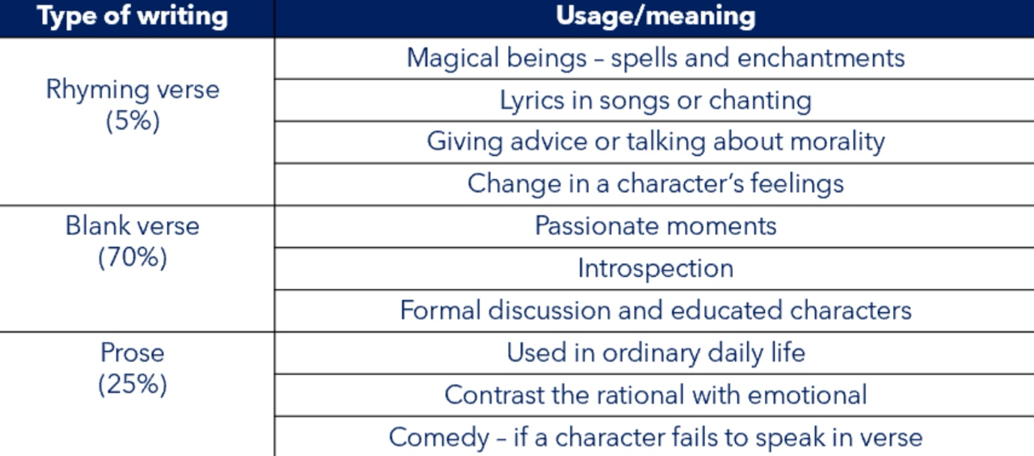

- Why is a change in writing style important?
A change in writing style is important as it signifies a change, emphasises a particular point or change in thought.

- Please briefly describe Iambic Pentameter
- Iambic pentameter refers to ten syllables in a line of five iambs.
- An iamb is a pair of syllables, in which the second syllable is stressed.
- Iambic is the natural rhythm of the English language!
- Ex: To me | fair friend | you nev | er can | be old
- This is a pattern of rhythm, or meter, in which most lines contain five unstressed syllables each followed by a stressed syllable
- His plays were written in blank verse, or unrhymed lines of iambic pentameter

