IDX G9 HISTORY H STUDY GUIDE ISSUE 1
By Daniel Zhang
- 1.3 BEGINNING OF CIVILIZATION
  - Prehistory
    - Old Stone Age: Paleolithic (2.4 million BCE to ~10,000 BCE)
      - Human species evolve and compete
        - Learned using simple tools and fire
        - Nomadic hunter-gatherers
        - Started using languages
      - Society
        - Labor divided by genders
          - Men: hunt, fight, heavy labor
          - Women: gather, cook, raise kids
        - Tribal
          - Extended families
          - Small population
        - Artistic expression (cave paintings)
          - Site: Lascaux, France (15,000 BCE)
        - Religious beliefs
          - Burying the dead
          - Animism: a world full of spirits
    - Middle Stone Age: Mesolithic
      - The transition between the Old Stone Age and the New Stone Age
    - New Stone Age: Neolithic (10,000 BCE – ~3,000 BCE)
      - Agricultural revolution
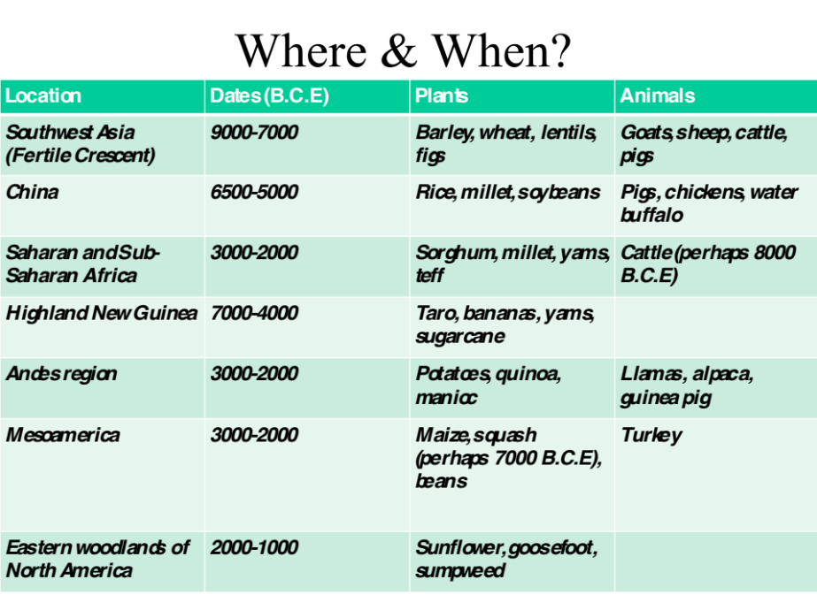
        - River Valley Civilizations
          - Bronze Age (4,000 BCE)
            - Metalworking first started with copper
            - Started using a bronze mixture of copper and tin
            - Sometimes independently (ex: China and Mesopotamia)
          - Civilizations Emerge (~3,500 BCE)
            - Developed around river valleys
            - Tigris and Euphrates rivers (Iraq)
            - Nile River (Egypt)
            - Indus River (Pakistan/India)
            - Huanghe (China)
        - 8 Features of Civilizations
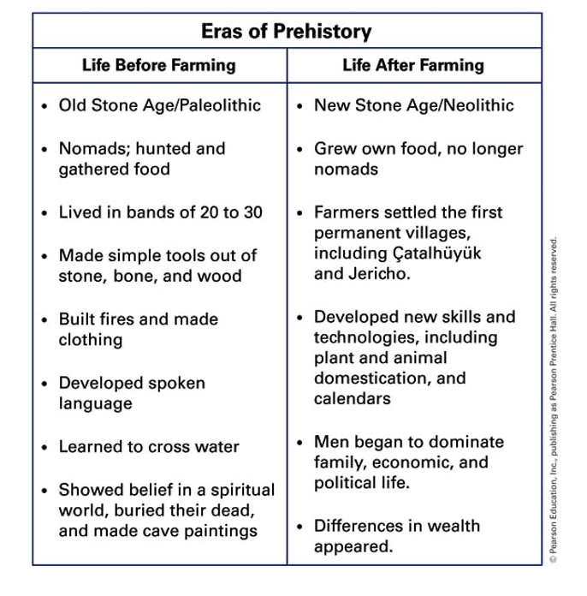
          - Cities, Organized Government, Complex Religions, Job Specialization, Social Classes, Arts and Architecture, Public Works, and Writing.
  - 2.1 CITY-STATES OF ANCIENT SUMER
    - Mesopotamia (Oldest know civilization)
      - Poem The Epic of Gilgamesh
        - First told orally in Sumer
        - Describes a great flood that destroyed the world
      - Collection of tightly organized city-states
        - Government: KINGS & COURTS
        - Society: CLASS SYSTEM & SLAVERY
        - Irrigation of crops
      - Tigris and Euphrates
        - POSITIVES:
          - Plenty of fresh water
          - Access to trade, travel and cultural diffusion. (Traded grain, cloth, and tools, brought in stone, wood, metal.)
          - Silt deposited by rivers. (Mainly grew barley, wheat)
        - NEGATIVES:
          - Unpredictable flooding
          - No natural barriers to invasion. (Using walls of mud bricks to defend)
      - Sumerian Civilization
        - Trading
          - With Egyptians and Indus Valley
        - Astronomy, mathematics (based on 6), sailing, plow, wheel, bronze, Ziggurats etc.
        - Writing
          - Cuneiform (earliest)
          - Wedge
          - Pictographs (symbols for more complicated ideas)
        - Religion
          - Polytheistic
          - Afterlife
        - Social Hierarchy
          - Top: Ruling family, leading officials, high priests
          - Middle: Lesser priests, scribes, artisans
          - Bottom: Peasants, farmers, slaves
          - Women had fewer rights
        - Militaristic (soldiers powered) rulers must:
          - Protect
          - Build walls, irrigation
          - Hire scribes for taxes, records
          - Religious rituals
        - 12 city-states
        - Babylonians (1790 BCE) conquered most of Mesopotamia
Under Hammurabi
            - Code of Hammurabi
              - Legal standards
              - Civil vs. criminal law
            - Ruled ~30 years
            - Prospered
              - Controlled trade routes
              - Encouraged literature
  - 3.1 INDUS RIVER VALLEY & INDIAN SUBCONTINENT
    - Geographical Features
      - Indian Subcontinent
        - Large landmass that juts out from a continent.
        - Huge peninsula extending into the Indian Ocean.
      - Gangetic Plain
        - Rivers: Indus, Ganges, Brahmaputra
      - Deccan Plateau
        - Parts are arid, agriculturally unproductive, sparsely populated.
      - Eastern & Western Ghats
      - Monsoon
        - Seasonal winds that regularly blow from a certain direction for part of the year.
    - Two major cities: Mohenjo-Daro and Harappa.
      - Carefully planned, organized pattern: long wide main streets and large rectangular blocks.
      - Building materials: Mud and unbaked bricks
      - Complex plumbing systems: Baths, drains, water chutes led into sewers
      - Uniform system of weights and measures.
    - Aryan Civilization: “The Vedic Age” (1500 BCE-500 BCE)
    - Classical India ~500 BCE
      - Rival kingdoms
      - Acculturation
        - Blending of Aryan and Dravidian traditions
      - Sanskrit: written language
    - MAHABHARATA
      - One of two major Sanskrit epics of Ancient India (Ramayana is the other)
      - Revered in Hinduism
      - Philosophical and devotional material
      - Author is Vyasa?
      - Compiled between 3rd century BCE and 3rd century CE
      - 200,000 verse lines 1.8 million words
      - Compared to Bible / Quran in its importance to world civilization
  - 2.5 ROOTS OF JUDAISM
    - Jews experienced Persecution over many centuries.
    - In the 1800s many Jews started to believe in Zionism – a movement for their own Jewish country
    - Hebrew
      - Ancient language of Judaism
      - Ancient Jews: Hebrew or Israelites
    - Ancient Israel
      - Birthplace of 2 monotheistic religions: Judaism, Christianity
      - Patriarchs (creator/leader) of Judaism: Abraham, Jacob, Moses, Joshua
      - Roots of Israel
        - Originated from Mesopotamia, which dominated by polytheism
        - Nomadic tribes wandered into Palestine from east, ~1900 BCE
        - God (Yahweh) told Abraham “To go and rase a great nation”
        - Settled in Canaan
        - Origins
          - Exodus
          - Israelites forced to leave the promised land, settled in Egypt, enslaved
          - Moses led to freedom
          - Returned to Canaan, but land taken over by other groups
          - Lead to Diaspora
        - Holy Places
          - Israel – Promised land
          - Jerusalem
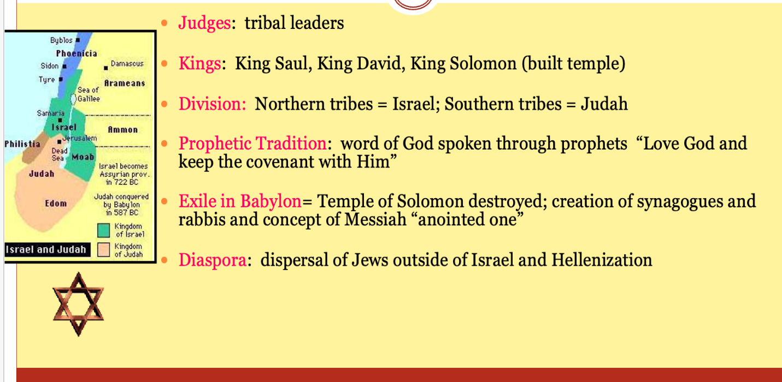
            - The “Wailing Wall” or “Western Wall”
  - 4.2 CLASSICAL GREECE
    - Greek Dark Ages
      - 1100 ~ 800 BCE
    - Divided by mountains
    - Seas provided link to world
    - Good sailors/colonizers/traders
    - Scattered poleisa
  - CONFLICT IN THE GREEK WORLD
    - The Persian War
      - Start
        - Persians conquered the Greek city-states of Ionia in Asia Minor.
        - 499 B.C., Athens sent ships to help the Ionian Greeks rebel against Persian rule.
      - Athenians Win at Marathon
        - 490 B.C. Persian army landed near Marathon.
        - Athenians used hand-to-hand combat to defeat the Persians.
      - City-States Unite
        - In 480 B.C., Darius (the previous leader of Persians)’s son Xerxes sent a stronger force to conquer Greece, but Athens had already united with nearby city-states and thus grew a stronger force.
        - The first defensive army of Greece was made up of the Spartans, and they were defeated in the end. The Persians kept marching south and burnt the city of Athens (the people of Athens had already withdrawn to safe places).
        - Athenians used the fleet of boats which the king of Spartans had built to defeat the Persians. Athenians lured the Persian Navy into the narrow strait of Salamis and used the underwater battering rams to attack the enemy boats. As a result, the Persian Navy sank.
        - In 479 B.C., the Greeks defeated the Persians in Asia Minor.
      - Creation of the Delian League
        - Athens was the most powerful city-state during the war. Thus, Athenians organized an alliance (agreement) between two or more city-states to cooperate and come to one another’s defense. It was known as the Delian League.
        - Athens gained its position among the Delian League, and slowly created an Athenian Empire.

