IDX G9 PHY H STUDY GUIDE ISSUE 1
By Anthony Zheng
- 2.5, 2.6 Motion at Constant Acceleration
  - a=constant, straight line
  - 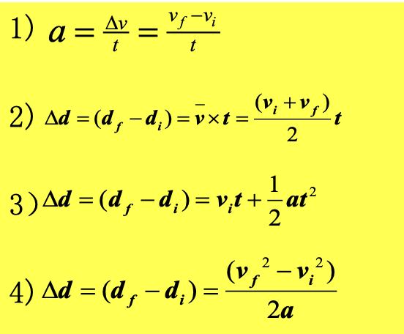
- 2.7 Falling Objects
  - Free fall
    - Motion of a falling object when action can be considered due to gravity alone
  - Acceleration due to gravity on earth, g=9.8 m/s^2
  - Important to define direction of gravity when doing questions
  - Use the 4 equations to solve for different scenarios, regardless if there is a initial upward/downward velocity or not
- 2.8 Graphical Analysis of Linear Motion
  - Position-Time Graph
    - No motion: horizontal straight line
      - 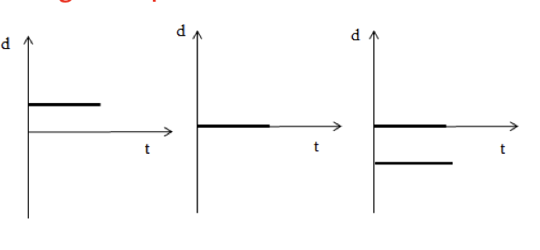
    - Uniform Motion
      - Slanted straight line
      - Y intercept: initial position
      - Intersection of lines: two objects meet
      - Average velocity: slope of the line
      - Instantaneous velocity
        - average slope/velocity
    - Many Straight Lines
      - Many different velocities
      - Velocity = slope
    - Curve
      - average velocity: slope of connection of the two dots on the line
      - instantaneous velocity: slope of tangential line to the curve
    - 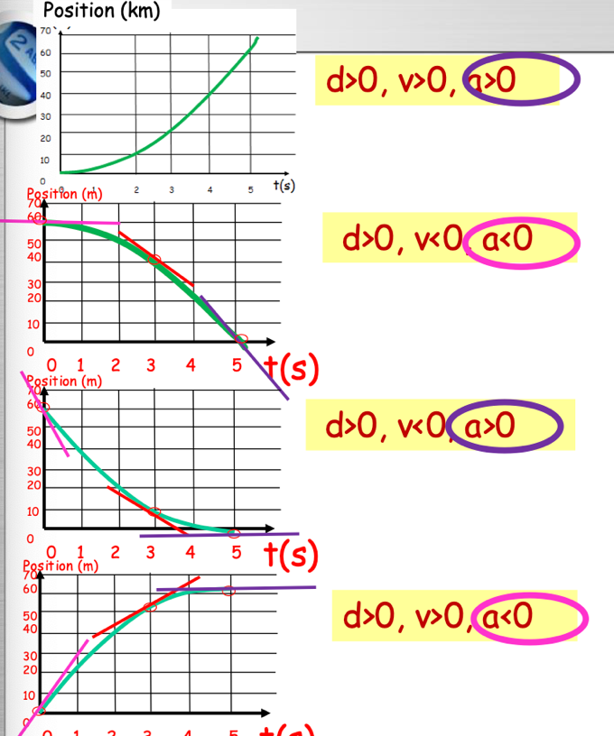
  - Velocity-Time Graph
    - Horizontal line
      - Velocity is constant
      - Y axis: v of an object
      - Area under graph line is displacement
      - Meet, when area is the same
    - Uniformly accelerated line
      - Slanted straight line
      - Slope= average acceleration
      - Rising: a>0, Falling: a<0
      - Steeper the slope is, larger the magnitude of a is
    - Motion with changing a
      - Instantaneous acceleration = slope of the tangent to the curve
  - Acceleration-Time Graph
- 3.1 Vectors and Scalars
  - Vector has magnitude and direction
  - Scalar only has magnitude, no direction
  - How to represent the vector?
    - Line and an arrow
      - Length: Magnitude
      - Direction: Direction of Vector
    - Direction of a Vector
      - Remember to define your direction, or include it in the final answer
      - You can use:
        - Rectangular coordinates (40 degrees North of East)
        - Direction: Up, Down, Left, Right, etc.
      - Measuring in Different ways
        - 30 degrees West of North is the same as 30 degrees above -y
        - 30 degrees West of South is equal to 30 degrees 60 degrees South of West
        - If the question provides you any compass directions, it is best to use them
    - Draw to scale
      - Use your ruler and a compass to draw out vectors
      - You can also use scale bars to represent larger vectors
- 3.2 Addition of Vectors – Graphical Methods
  - Tail to Tip Method
    - Move the tail of one vector to the head of another vector
    - Resultant points from tail of first vector to head of last vector
    - If three or more vectors form a closed polygon, there is no resultant
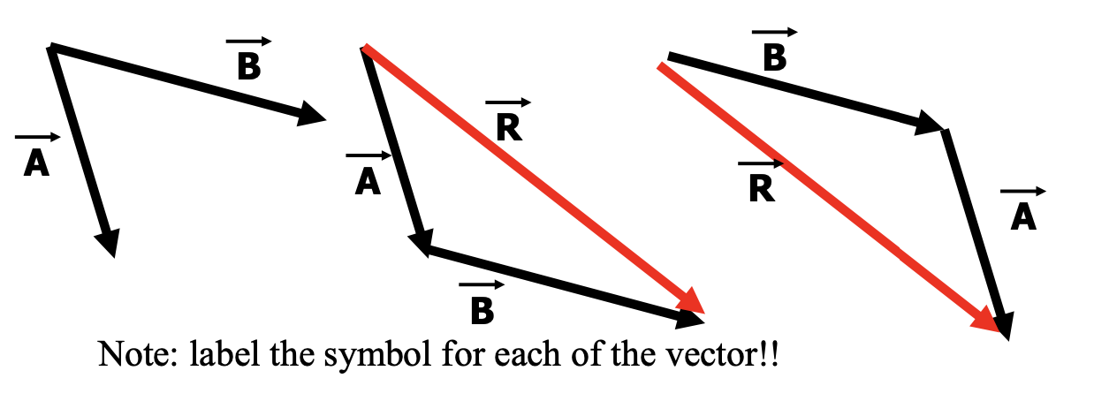
    - Does not matter which order you do this in
    - If vectors are in one straight line,
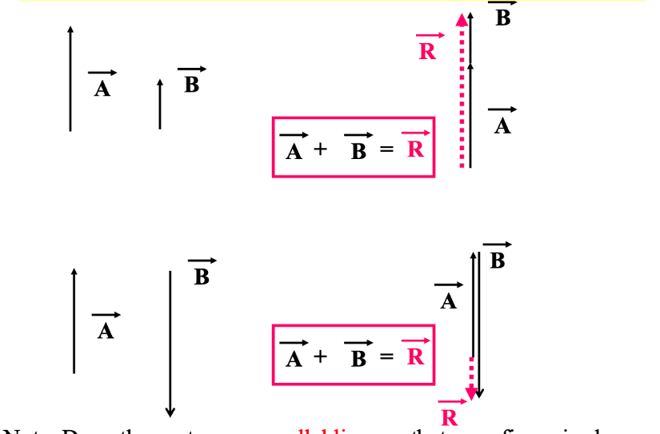
      - Draw the vectors on close parallel lines so that it is clear
    - Practice Questions
      - Draw the resultant vector and calculate the net displacement to scale if a person walks 8km east then 6km north after
      - T or F: Magnitude of vector sum is always greater than the magnitude of either contributing vector
      - T or F: Can the magnitude of a vector ever (a) be equal to one of its components, or (b) be less than one of its components
      - A boat travels at 30 m/s due east across a river that is 120 m wide and the current is 12 m/s south. What is the velocity of the boat relative to shore? How long does it take the boat to cross the river? How far downstream will the boat land?
    - Wind
      - Tailwind: coming from behind and increasing velocity
      - Headwind: coming from the front, decreasing velocity
      - Crosswind: coming from the side, can influence both horizontal and vertical components
  - Parallelogram Method
    - Place component vectors tail-to-tail
    - Construct a parallelogram
    - Diagonal from common origin is the resultant vector
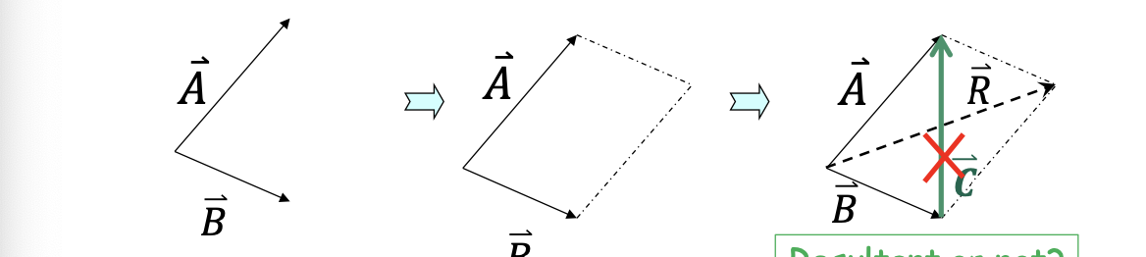
  - Pythagorean Theorem
    - You can use the Pythagorean Theorem to not only calculate the vector magnitude, but also angle
    - When calculating, you can use arctan (b/a) to find a certain angle, if the angles between the vectors is 90!
    - 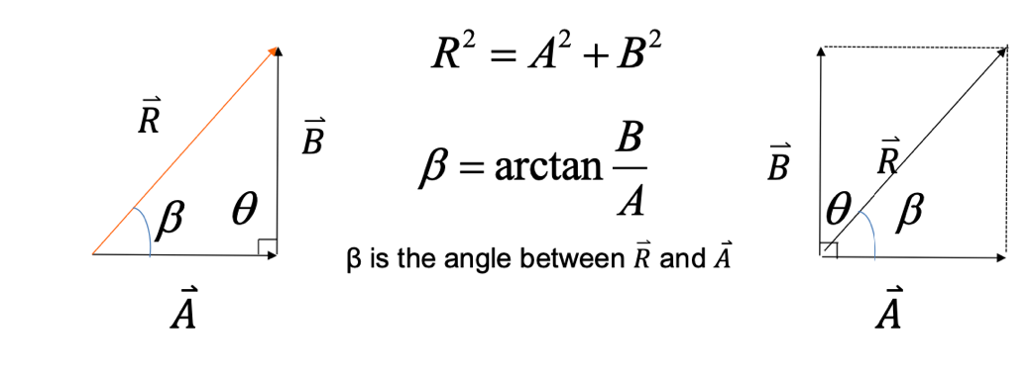
  - Q: Forces of 30 N due north and 40 N due east act on a mass. What is the net or resultant force on the mass?

- 3.3 Subtraction of Vectors, and Multiplication of a Vector by a Scalar
  - Subtracting Vectors
    - Negative Vectors
      - Two vectors are negative if they have same magnitude but opposite directions
    - A-B = A+(-B)
      - Subtracting two vectors is the same as adding its negative
  - Multiply the Vector
    - Vector A can be multiplied by scalar C
      - If C is positive, then product has same direction and magnitude CA
      - If C is negative, product has opposite direction and magnitude CA

- 3.4 Adding Vectors by Components
  - Vector Components
    - Break down the vector into x, y components
      - Vector resolution
    - Fundamental Trigonometry
    - 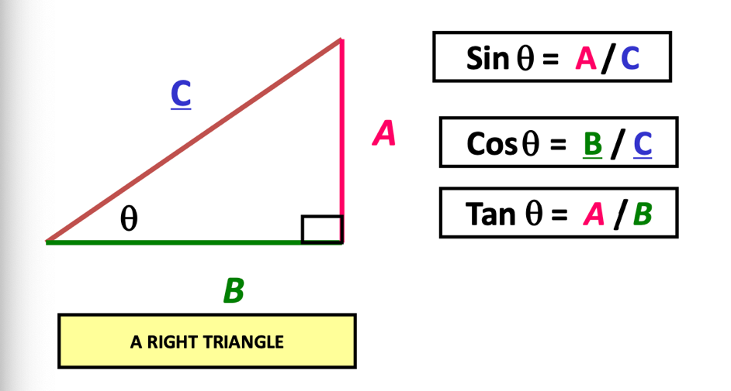
    - X and Y components of a vector
      - Use the Pythagorean theorem to find the resultant vector
      - Or you can use cosine and sine to find the x, y components
  - Adding vectors using components
    - Resolve each vector into x and y components
    - Add the x components of all the vectors, and add all the y components
    - Get the resultant using Pythagorean theorem (where you use the sum of each component to find the resultant)
    - Find angle using arctan
  - Questions
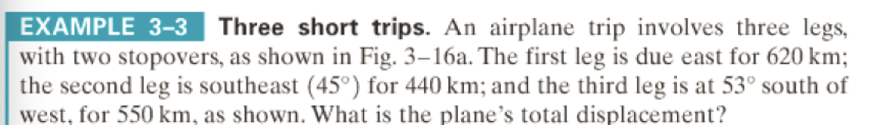
    - A GPS receiver indicates that your home is 15.0 km and 40.0o north of west, but the only path through the woods leads directly north. If you follow the path 5.0 km before it opens into a field, how far, and in what direction, would you have to walk to reach your home?

- 3.5 Projectile Motion
  - Concepts of projectile motion
    - Projectile: object shot through the air
    - Trajectory: curved flight path that is followed by a moving object
    - Ignoring air resistance, net force on an object after it is launched is gravity
    - Combination of two independent motions
      - Horizontal motion component: constant velocity (given no air resistance)
      - Vertical motion component: motion with constant acceleration
  - Projectile launched horizontally
    - No initial vertical velocity
    - 1. Analyze the horizontal and vertical motion separately
      - Horizontal: constant v
      - Vertical: free fall
    - 2. Velocity vector always tangent to the parabola at any point
    - 3. Horizontal and vertical motions are independent
      - Time from launch to hit the target is the same
    - 4. What affects the range?
      - Horizontal velocity
      - Flight time (influenced by height it falls)
    - How to solve:
      - Given: Y values
        - Calculate how much time it will take for free fall
        - Horizontal velocity times time is range
      - Given: X values
        - Find the time using d/v
        - Plug that into equations to find height or other values
  - Projectile launched at an angle
    - Separate the initial velocity vector into x and y components
    - Max Height: height of projectile when vertical velocity = 0
    - Level Horizontal Range: horizontal distance projectile travels before returning to original height
    - Flight Time/Hang Time: how much time the projectile is in the air
    - Solving method is similar to horizontally launched projectiles, except now there is an initial vertical velocity in the equation, so it is similar to throwing objects up/down
    - 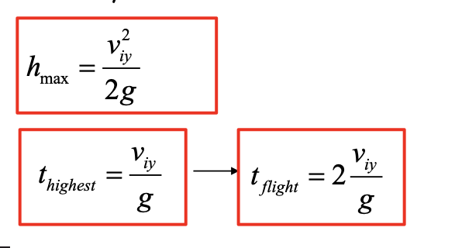
- 3.6 Solving Problems Involving Projectile Motion
  - A player kicks a football at an angle of 45° above the horizontal. The football has an initial velocity of 10.0 m/s.
    - Find:
    - a. the flight time,
b. the maximum height
    - c. the range of the football.
    - d. Find the velocity and a of the ball at the maximum height
    - e. Find the velocity of the ball 0.5 second later after it’s launched.
  - 