IDX G9 PHY S+ STUDY GUIDE ISSUE 1
By Gordon
2.1 Reference Frames
INTRODUCTION
- MECHANICS: study of motion and force
  - KINEMATICS: study of motion
  - DYNAMICS: study of force
- RECOGNIZING MOTION
  - An object is in motion if it changes POSITION relative to a FRAME OF REFERENCE
  - Whether an object moves depends on your POV(Point of View)
  - REFERENCE POINTS (FRAME OF REFERENCE)
      - A PLACE OR BACKGROUND used to compare whether an object is in motion or not. (ALWAYS ASSUMED AS STATIONARY)
- PICTURING MOTION
  - MOTION DIAGRAM
      - A series of a series of images showing the positions of a moving object at equal time intervals.
      - Purpose: visualize displacement and velocity
  - PARTICLE MODEL
      - a simplified version of a motion diagram in which the object in motion is replaced by a series of particles.

VECTORS AND SCALARS
VECTOR
      - Quantities which has a DIRECTION and a MAGNITUDE (size)
SCALAR
      - Quantities which have magnitude but no direction .

DISTANCE AND DISPLACEMENT
  - DISTANCE
    - Scalar
    - The accumulation of path
  - DISPLACEMENT
    - Vector
    - distance move in a particular DIRECTION
2.2 + 2.3 Average Velocity + Instantaneous Velocity
SPEED
  - Distance an object travels / unit of time
  - Formula: Speed=distance / time (v=d/t)
  - Instantaneous Speed: Speed at a particular moment
AVERAGE SPEED
  - when speed is not constant —> average speed = total distance / total time
  - when speed is constant —> constant speed motion
VELOCITY
  - speed in a given direction
  - can be shown with an arrow
  - use + or - to represent direction when move in a straight line
  - direction is very important
  - average velocity = total displacement / time
  - Instantaneous velocity : Velocity at particular instant of time

2.4 Acceleration
  - the rate at which an object’s velocity changes
  - a = v / t = Vf - Vi / Tf - Ti
  - instantaneous acceleration: the CHANGE in velocity at an INSTANT of time
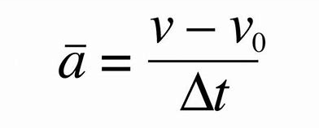
2.5 Motion at constant acceleration + 2.6 Solving Problems
Formulas
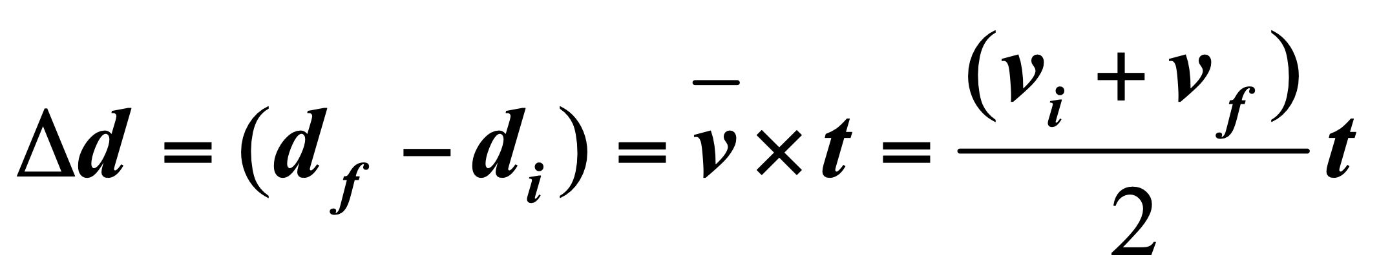
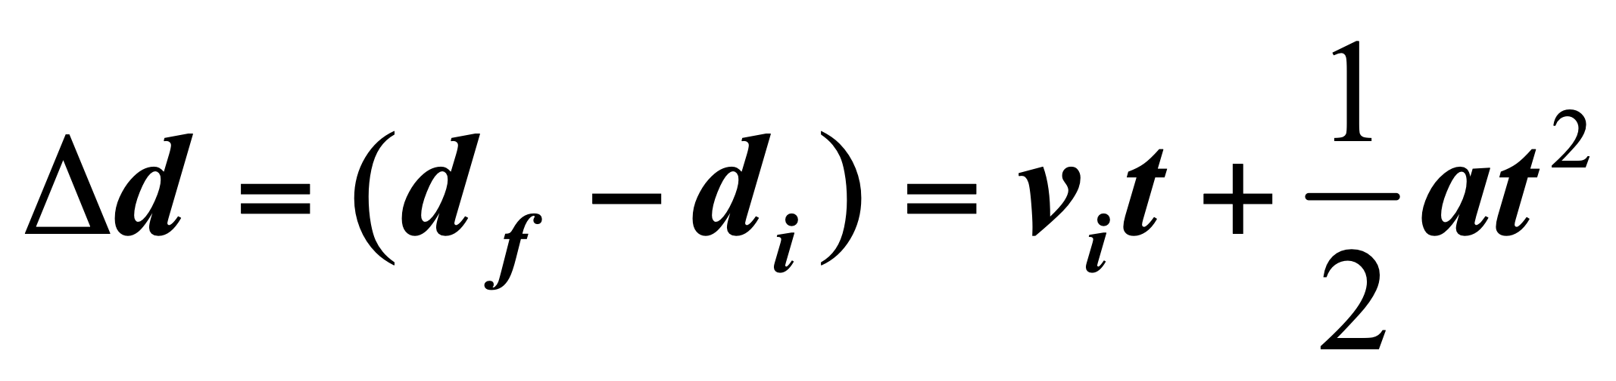

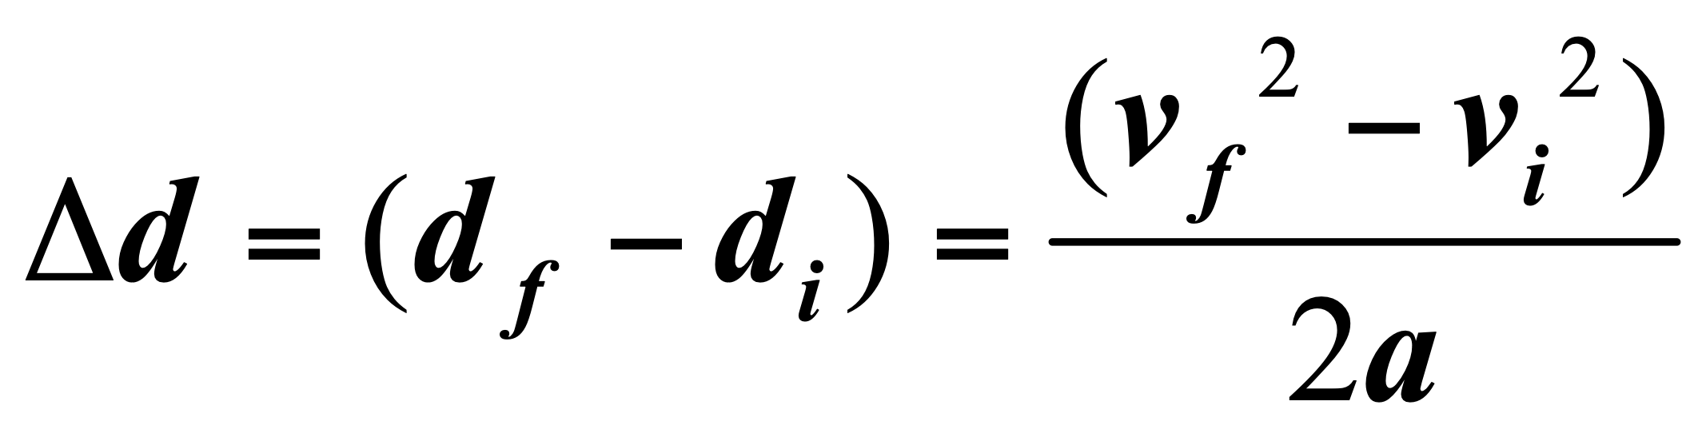

2.7 Falling Objects
Free Fall
  - The motion of a falling object when air resistance is negligible and the action can be considered due to gravity alone.
  - Aristotle: heavier objects falls faster
  - Galileo’s Thought Experiment
  - Galileo’s Model
    - Steeper Incline —> faster acceleration
    - Incline=vertical: Maximum Acceleration
    - All objects fall at g(g=9.8m/s^2)neglecting air resistance
  - Galileo’s Hypothesis
  - at a given location on the Earth and in the absence of air resistance, all objects fall with the same constant acceleration.
Acceleration due to gravity
  - No matter what the falling object is made of
  - No matter how much it weighted
  - No matter what height it was dropped from
  - No matter whether it was dropped down or thrown upward
  - Small variations in g at different LATITUDE and ELEVATION on earth
  - +g = downward to be positive; -g = upward to be negative
Distances of free falling from Vi=0
  - Vi=0, d=1/2gt^2

