
NOTE: This is an official document by Indexademics. Unless otherwise stated, this document may not be accredited to individuals or groups other than the club IDX, nor should this document be distributed, sold, or modified for personal use in any way.
IDX G9 PHYSICS H STUDY GUIDE ISSUE 5
By TaeYun K and Eric W

5-3: Highway Curves, Banked and Unbanked
Unbanked Curves: Curves that are not sloped
- When a car goes around a curve: $F_{net}=F_{fs}=F_{R}$
  - $F_{fs}$ is the centripetal force
    - No $F_{R}$ = Car goes straight
    - There is NEVER a Centrifugal force
- If the $F_{fs}$ is not sufficient, the car will tend to move more nearly in a straight line (due to Newton’s 1st law)
  - As long as the tires don’t slip, the friction is static
  - If they slip, the friction is kinetic, which is bad in 2 ways:
    - The $F_{fk}<F_{fs}$
    - The $F_{fs}$ points toward the circle center, but $F_{fk}$ opposes that, making it difficult to regain control of the car & continue around the curve
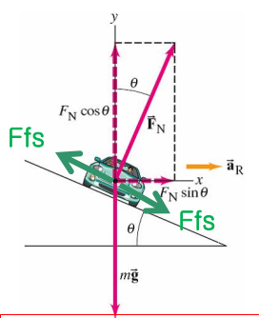
- Unbanked Curve’s Maximum Velocity: $V_{max}=\sqrt{μ_{s}gr}$
  - $V_{max}$ is independent of the mass of the car

Banked Curves:
- Banked turns: using a slope/hill/angle to help us turn safely
- Designed velocity for a banked curve with angle θ
  - For every banked curve, there is one v where no friction is required
    - $v=\sqrt{gr\tan{θ}}$ (Design speed)
    - If $v>\sqrt{gr\tan{θ}}$ then $F_{fs}$ increases the $F_{net}$
    - If $v<\sqrt{gr\tan{θ}}$ then $F_{fs}$ decreases the $F_{net}$
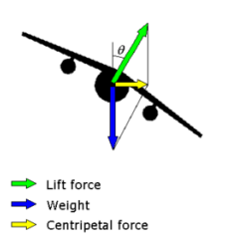
    - Banked v is also independent of the mass of the car
- Why use banked turns?
  - To allow us to not rely on friction when turning on a road
  - To allow planes to turn (as they don’t have friction)
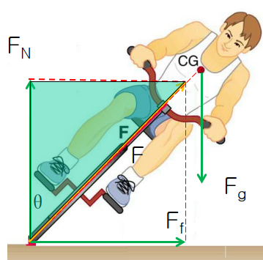
  - To allow race cars to go at faster speeds
  - To help with the wear and tear or your tires
- Free body diagrams of:
  - A car
  - A plane
  - A person on a bike

5-6Newton’s Law of Universal Gravitation
- Statement
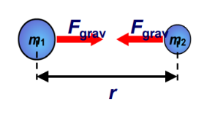
  - Every particle in the universe attracts every other particle with a force that is proportional to the product of their masses and inversely proportional to the square of the distance between them. This force acts along the line joining the two particles
- Formula:
  - $F_{g}=G\frac{M_{1}M_{2}}{r^{2}}$
  - G = Universal Gravitational Constant = 6.67 × 10⁻¹¹ Nm²/kg²
  - Englishman Henry Cavendish measured the gravitational force between two objects in 1978
    - Used device made by John Michell
    - Cavendish intended to measure the density of Earth, but we can get G from that
  - Conditions to apply the formula:
    - Two particles separated distance r away
    - Extended objects: small size compared to the distance r
    - Extended objects: r and the size are comparable, then use integral calculus
